Voxone user guide

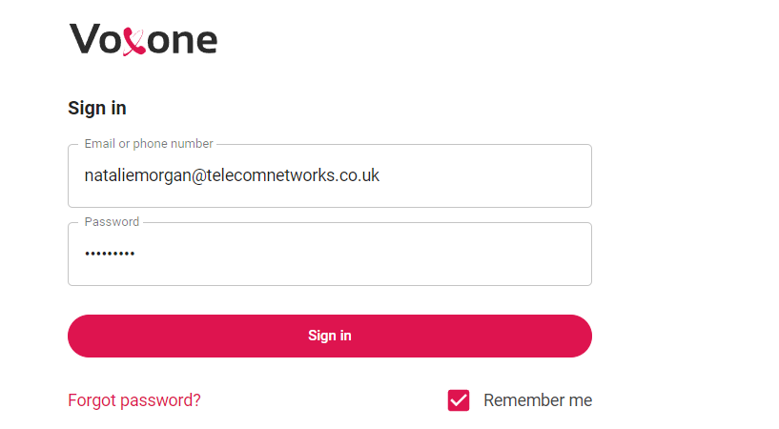
- Login to your Voxone app, You will be presented with the screen below. Type in your username & password.

- Once you have signed in you will see the dashboard below, as you can see all contacts are down the left hand side and you can use the search box to either search for a contact in the directory or just type a number as when you start typing it will come up a green box which says call. (See below)
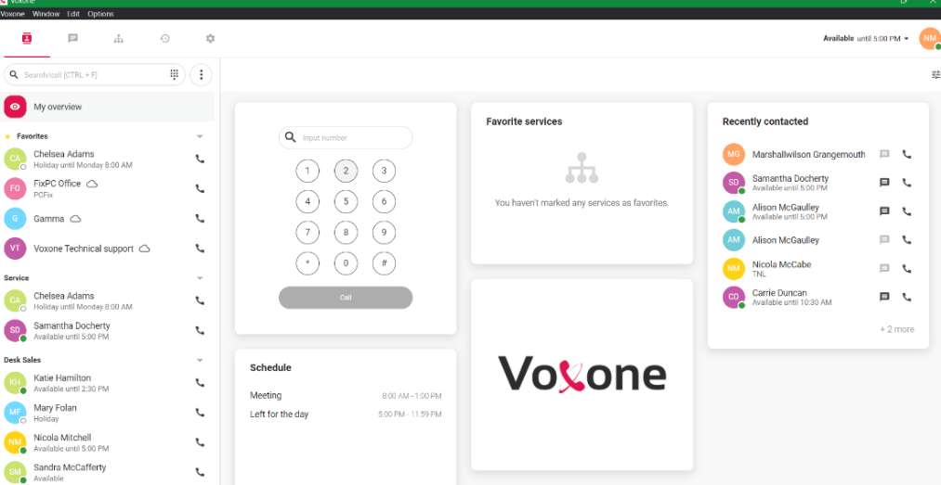
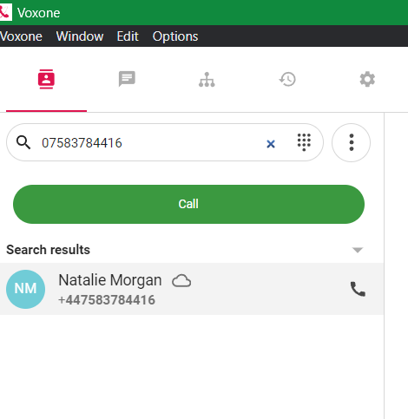

- Once you are on a call it comes up at the right-hand side and this is where you can see the hold, transfer & mute options (See below)
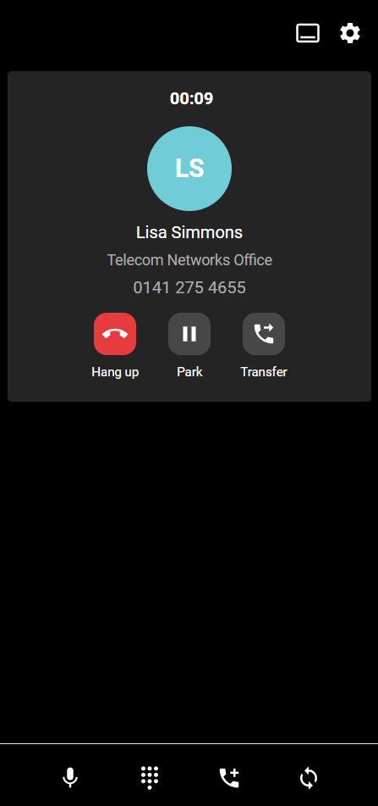
To place a call on hold, press park.
To resume the call press unpark 

To transfer a call, press the transfer button, you will then see the screen below
with this screen you can either transfer to an internal colleague or you can type an external number in the search box. Once you have your number click transfer call at the bottom.

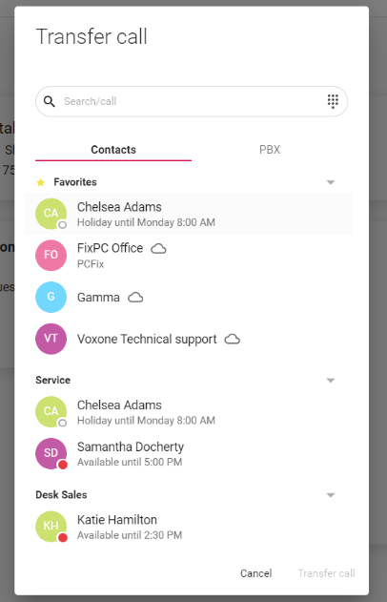

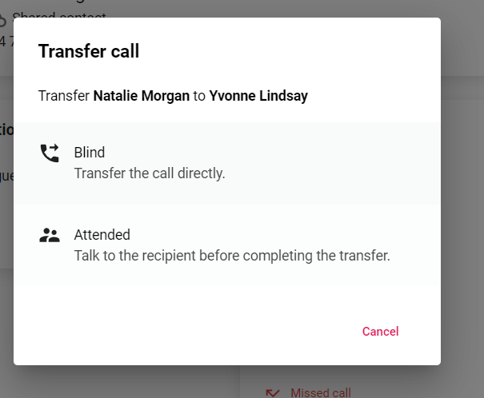
Once you have hit transfer call you will then see this screen which gives 2 options. Blind transfer will just transfer the call without speaking to the person first but attended means you can speak to the person and say who you have on the phone and allow them to say yes or no to the call. If they say no then just hit cancel and you have the original call back. bottom.

